Design bugs

1. Summary: Design bug on home page

1.Navigate to http://qaf2017demo1-001-site1.dtempurl.com/
2.Log in with the admin password and username
3.On the home page should be a list of the popular songs

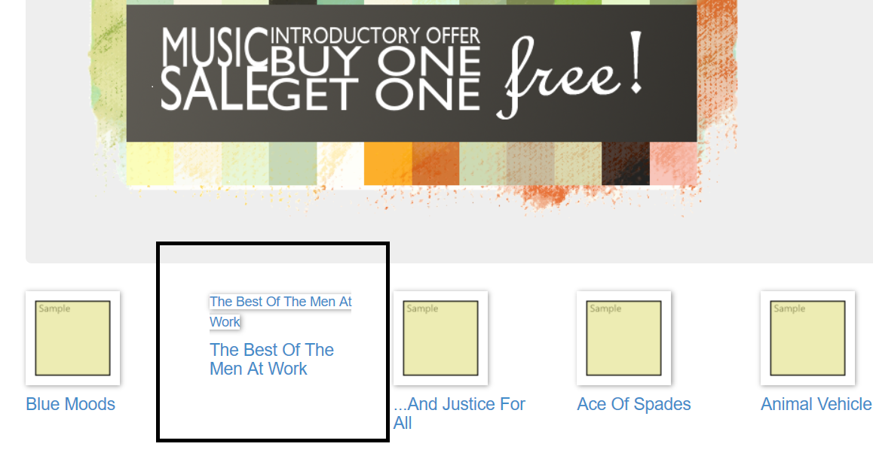

Expected result: All of the enlisted songs to be with the same design
Actual result: One of the songs title is misplaced.

2. Summary: Broken images on home page

1.Navigate to http://qaf2017demo1-001-site1.dtempurl.com/
2.Log in with the admin password and username
3.On the home page should be a list of the popular songs with images

Expected result: All of the enlisted songs to be with the same design and visible images
Actual result: None of the images are visible.

3. Summary: Misalignment on home page

1.Navigate to http://qaf2017demo1-001-site1.dtempurl.com/
2.Log in with the admin password and username
3. Enter the Music Store page
4. Choose an album from the ones enlisted on the page
5.The font of the style and the word “albums” are different

Expected result: All of the enlisted items to be with the same font and visible images
Actual result: The images are broken and the fonts are different

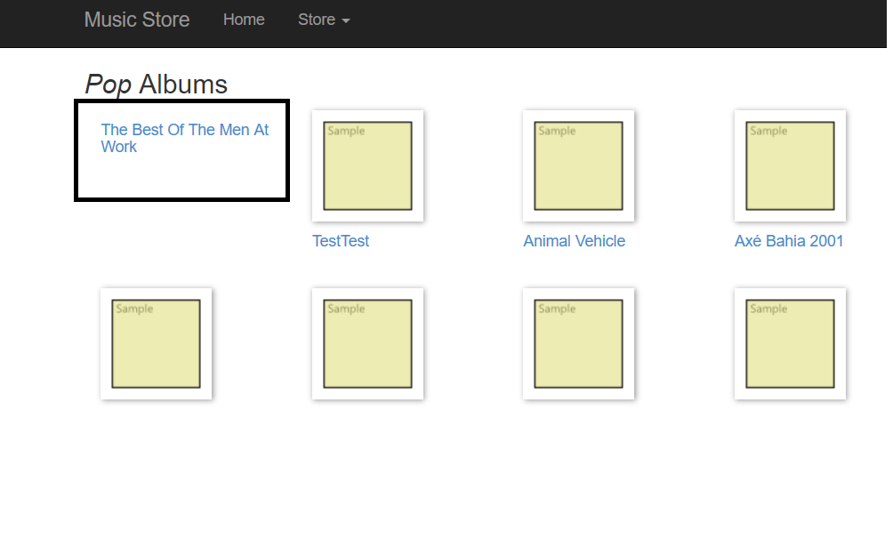
5.Design bug on home page
1.Navigate to http://qaf2017demo1-001-site1.dtempurl.com/
Expected result:
-to load header, navigation bar and a list of the most popular songs with images
Actual result:
- it loads header, navigation bar and and a list of the most popular songs with images that are not visible

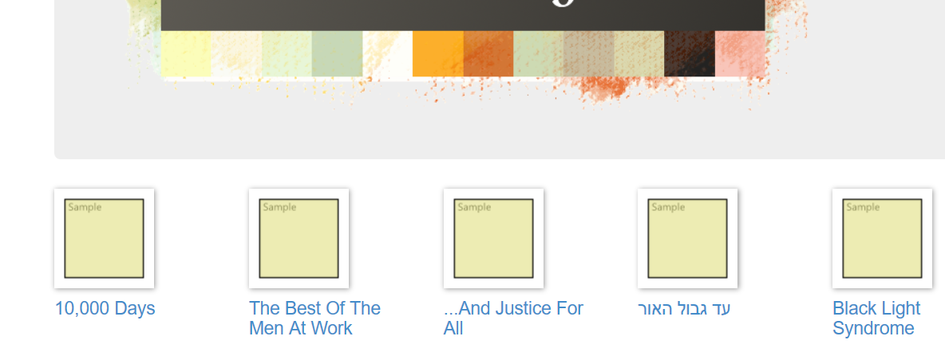
6. Summary: Design bug on the Music Store page

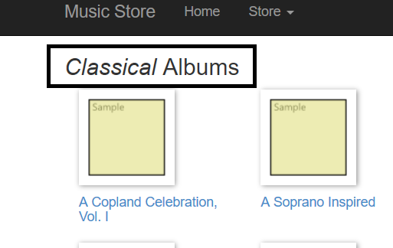
1.Navigate to http://qaf2017demo1-001-site1.dtempurl.com/
2.Log in with the admin password and username
3. Enter the Music Store page
4. Choose an album from the ones enlisted on the page
5.The font of the style and the word “albums” are different

Expected result: All of the enlisted items to be with the same font and visible images
Actual result: The images are broken and the fonts are different

